**// Subroutine : UpdateButtonClick_CUSOMTIZE_YOKE()**

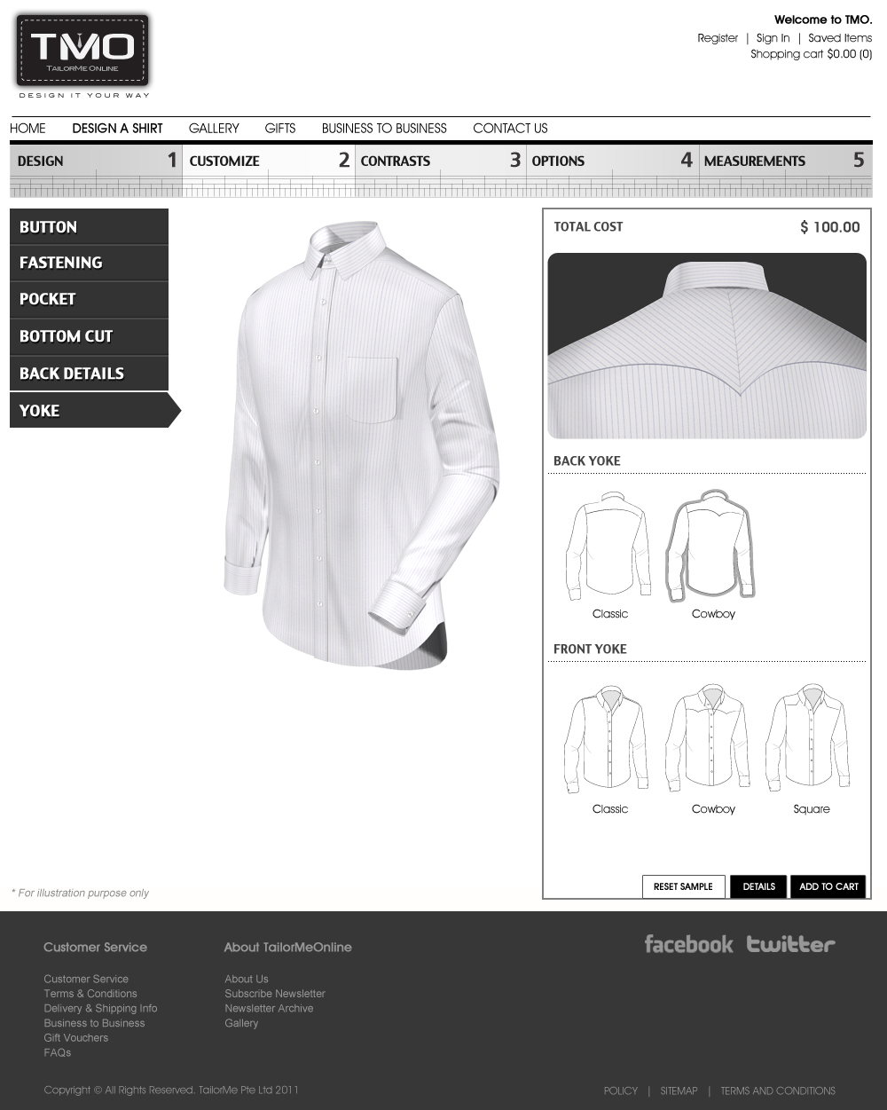

//------------------------------------------------------- Back Yoke

Upon clicking “Classic”:

If (BackYoke[2] != “ClassicYoke.”) && (BackYoke[2] != “ClassicYokeCentreFold.”)

&& (BackYoke[2] != “ClassicYokeSideFold.”)

BackYoke[2] = “ClassicYoke.”;

Call Subroutine : RefreshFilenames();

Call Subroutine : DisplayBackYoke(); // This displays the back yoke

Upon clicking “Cowboy”:

BackYoke[2] = “CowboyYoke.”;

Call Subroutine : RefreshFilenames();

Call Subroutine : DisplayBackYoke(); // This displays the back yoke

//------------------------------------------------------- Front Yoke

Upon clicking “Classic”:

ShirtLyr02[2] = “”;

ShirtLyr02[5] = “Hide”;

Call Subroutine : RefreshFilenames();

Call Subroutine : DisplayFullview(); // This updates the full shirt window

Upon clicking “Cowboy”:

ShirtLyr02[2] = “FrontYoke-YokeCowboy.”;

ShirtLyr02[5] = “Show”;

Call Subroutine : RefreshFilenames();

Call Subroutine : DisplayFullview(); // This updates the full shirt window

Upon clicking “Square”:

ShirtLyr02[2] = “FrontYoke-YokeSquare.”;

ShirtLyr02[5] = “Show”;

Call Subroutine : RefreshFilenames();

Call Subroutine : DisplayFullview(); // This updates the full shirt window

**// End of Subroutine : UpdateButtonClick_CUSOMTIZE_ YOKE()**